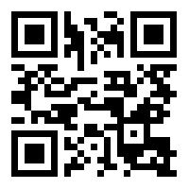

Map name - RRCP_Map_072320.pdf

Map location - [https://gisweb.wilco.org/drop/Parks/QRCode/RRCP_Map_072320.pdf](https://gisweb.wilco.org/drop/Parks/QRCode/RRCP_Map_072320.pdf%20)

or https://qrgo.page.link/RC3cW