**Williamson County Census PSAP 2020**

The data came from the Census website (<https://www2.census.gov/geo/pvs/48/>)

2010 Census data is called - partnership_shapefiles_18**v2**_48491

2020 Census proposed changes is called - partnership_shapefiles_18**v3**_48491

The ACS17 5 year estimate data came from the ACS website (Wilco received this data from Jim Castagneri with the Census) - <https://factfinder.census.gov/faces/nav/jsf/pages/searchresults.xhtml?refresh=t#none>

In the GUPS software (and in general if using ArcMap) it is highly recommended that you review the Census proposed changes first for your area of interest (AOI). If you agree with most of the changes and only need to make slight changes (or none), you can use this 2020 (v3) tract geography layer as the layer you make your edits on. If you don’t agree at all with the changes, you will need to use the 2010 (v2) tract geography layer and start from scratch.

At the city level, it is also recommended using the GUPS software to make your changes as the tools will help you validate your changes and ensure the changes you made will pass County, COG, and Census review.

**Joining ACS table to 2010 census tracts**

Before making the join you need to convert the “GeodId2” field in the ACS table to text so you can join to the TRACTID field in the PVS_18_v2_curtracts_48491 layer (2010 census tracts).

Open a blank excel workbook and import the ACS17 5 yr table.

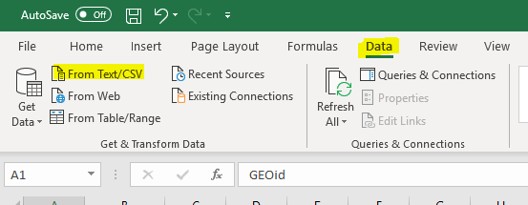

Edit the table to change the field type of the “GeoId2” field to text

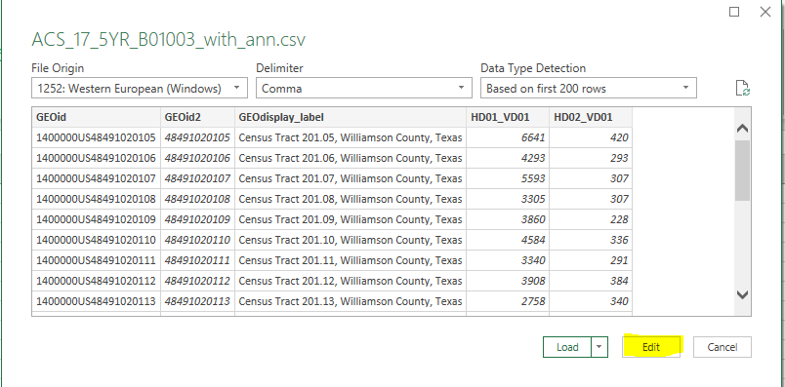

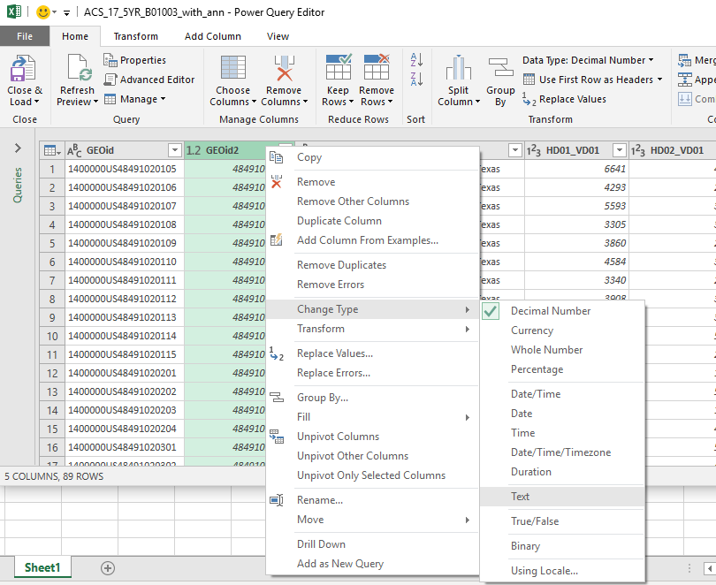

Save the file in .xls format and bring into ArcMap for joining to the PVS_18_v2_curtracts_48491 layer

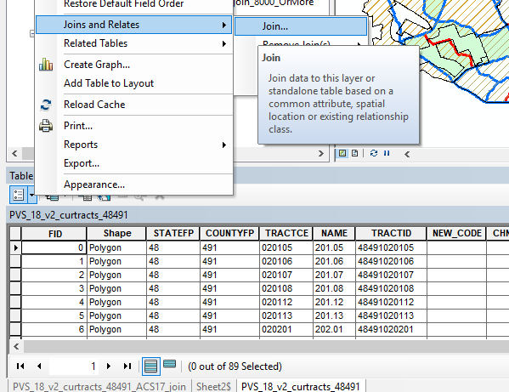

Populate the fields as shown below, validate the join, then click OK

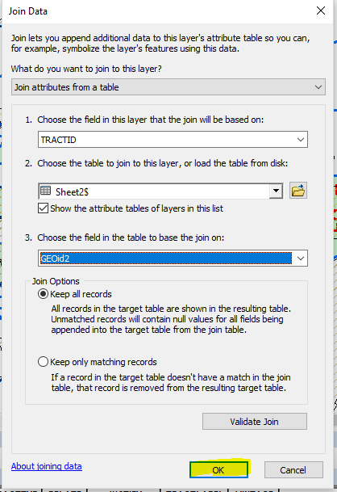

Create a layer from the join and name it something logical

Now do a Select By Attributes query on the new layer to select the tracts that have a population great than or equal to 8000 (the field “HD01_VD01” is the population field)

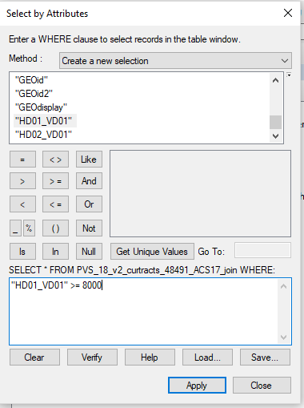

Export the selected features and name the layer something logical. These tracts are the ones that have to be split due to being over the Census designated threshold of over 8000.

You can take this even further and select/export out the tracts that are not above the max 8000 population to review. The below example is selecting the tracts that have 7000 to 8000 population.

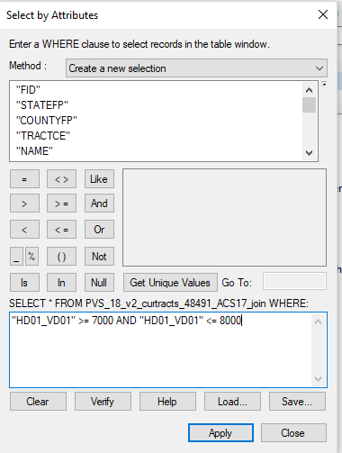

**5% Rule**

Below is an email excerpt from Jim Castagneri of the Census regarding the 5% rule:

“If any census tract is changed in a way that affects more than 5% of the decennial population for the tract, it must be re-numbered.  This is because of our comparability requirement.  This is true for splits/merges and for major revisions.  Sadly, while our guidelines for 2000 and 2010 had guidance on this, there is nothing in our 2020 guidelines.  Please use these statements from the **2010 guidelines** for guidance:

**3.2.3 Comparability (redefining census tracts)**

Comparability has always been a goal in the CT program since its inception for the 1910 Census; however, as the use of CT data increases, the importance of comparability increases. Maintaining comparability of CT boundaries over time facilitates longitudinal data analysis. The advent of the ACS and the averaging of sample data for CTs over a five-year span further underscore the need for consistent CT boundaries over time. If a CT is revised to reflect change, then it can’t be used to measure that change.

**Pursuant to this goal of continuity and comparability, the Census Bureau requests that where a CT must be updated, for example to meet the minimum or maximum population/ housing unit thresholds, that the outer boundaries of the CT not be changed, but rather that a CT be split into two or more CTs, or merged with an adjacent CT.**

The Census Bureau strongly discourages changes to CT boundaries, except in specified circumstances (e.g., where the physical features of an area have changed greatly due to significant flooding or redevelopment), which the Census Bureau will review on a case-by-case basis. Participants may edit a CT boundary identified by the PSAP MTPS as not acceptable or questionable so that it follows a nearby acceptable feature if the change affects five percent or less of the Census 2000 population/housing units or area.

**When editing CT boundaries, remember that comparability is important to the CT program. Editing a questionable or ineligible CT boundary so that it follows a nearby acceptable feature is acceptable if five percent or less of the Census 2000 population/housing units are affected by the change.**

CTs revised for Census 2010 should not be recoded, unless altered so that comparability with their Census 2000 counterparts no longer exists. If assigning a new CT code, assign the next available code within the coding range used in the county but do not reuse a CT code used in the Census 2000 or previous censuses.”

In the image below this is how I determined the percent change in population if we were to follow the suggested tract boundary change (red line):

I selected the houses in the area below. These were address points that were non-commercial, utility, etc related. Then multiplied by the 2.5 people per household (8000 max pop/3200 max housing units = 2.5)

So, 59 selected houses X 2.5 = 148; 148 people / 5223 (ACS17 pop estimate for that tract) = 2.8%. Therefore, no need to renumber the tract.

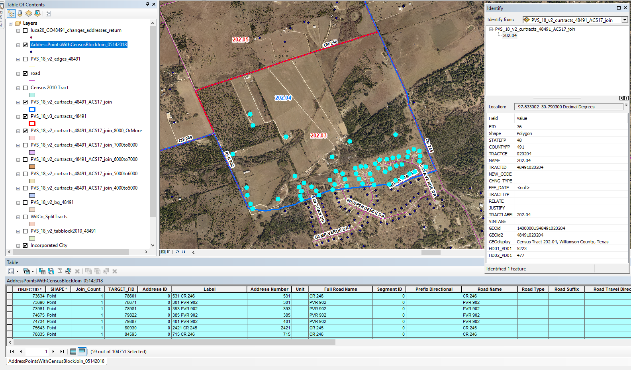

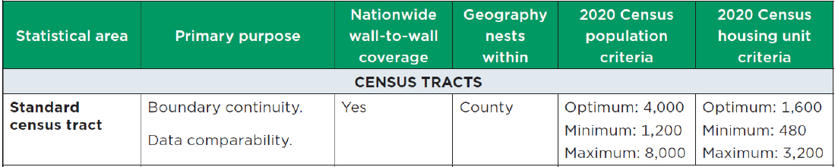

Another excerpt from Jim in response to the above analysis:

“…the primary reason they revised the boundary was to avoid splitting that subdivision...so, good call on their part.  From an ACS data quality standpoint, it's a good idea to revise boundaries when they cut through neighborhoods and/or the boundary no longer follows anything consequential.  The Census staff performing this review last year had no access to good local data, but they did have access to imagery.  Clearly, they reviewed the boundary 202.03 and saw that it split that subdivision in a non-sensible way and decided to revise the boundary.  In general, this is good practice.

However, the suggested split of 2010 tract 202.04 doesn't really make sense ...due to a population well within threshold.

In summary, allowing the suggested boundary change to tract 202.03 makes sense because it creates a better statistical boundary.  Even if the change was more than 5%, I might still recommend the boundary change in order to provide better data.  BUT it appears the number of affected housing units is below 5% so the **2010 number can remain the same for 2020**.”